MISSION REPORT ON IDENTIFICATION OF SITES FOR NEW AUTOMATIC RAIN GAUGES

- Introduction

From 24th to 28th August 2020 Meteo Rwanda staff: MUSONI Didace(Data Observation Quality Control and Processing Division Manager),NTIRENGANYA Desire(Instruments Maintenance and Calibration Officer) and UKWISHAKA David(Climate Change Data Officer) from REMA conducted a mission to identify proper sites where new automated rain stations will be installed. Those stations were donated by REMA in the project of LAFREC to Meteo Rwanda and are already supplied.
The main objectives of the mission were:
a. To identify suitable sites where the new stations must be installed;
b. Seek and acquire commitment of local leadership for the parcel of land where the stations will be installed.
c. Engage local leadership into protocols of security and safety of the station.
The visited sites are in the following Districts: Ngororero, Nyabihu, Rutsiro, Karongi, Nyamasheke and Nyaruguru.

- Purpose of replacing the old stations

During the discussion with REMA, it was agreed that some donated stations will be replacing aging ones.
An exercise was done to identify those stations to replace that are already proving problematic.
The table below shows different identified sites:

District | Site Name | Coordinates | Requirements | Person in contact
Ngororero | Muhororo Sector(Existing) | Longitude: 29.623872  Latitude: -1.892126  Altitude: 1748m | - New station  -To be relocated at 5m from previous location  - Fence: (5×5)m | Executive Secretary: 0783 327 366
Nyabihu | Mulinga Sector(New) | Longitude: 29.511008  Latitude: -1.711545  Altitude: 2562 m | - New station  - Fence: (5×5)m  -Leveling of land to be fenced | Executive Secretary: 0783 298 455
Karongi | Rugabano Sector(Existing) | Longitude: 29.480185  Latitude: -2.056508  Altitude: 2196 m | - New station  - Fence: (5×5)m | Executive Secretary:  0788 525 107
Karongi | Rwankuba Sector(New) | Longitude: 29.373186  Latitude: -2.161047  Altitude: 2334 m | - New station  - Fence: (5×5)m | Executive Secretary: 0788 845 057
Karongi | Ruganda Sector(New) | Longitude: 29.496765  Latitude: -2.218258  Altitude: 1870 | - New station  - Fence: (5×5)m | Social affairs  0783 420 992
Rutsiro | Bugarura Site (Existing Automatic Weather Station) | Longitude: 29.267082  Latitude: -1.917423  Altitude: 1502 m | - Fence: (6×11)m | Nurse: 0788 341 410
Nyamasheke | Kanjongo Sector | Longitude: 29.136600  Latitude: -2.318444  Altitude: 1518 m | - New station  - Fence: (5×5)m | Executive Secretary: 0785 813 835
Nyaruguru | Muni Sector | Longitude: 29.536054  Latitude: -2.713723  Altitude: 1993 m | - New station  - Fence: (5×5)m | Executive Secretary: 0788 830 036
Nyaruguru | Mata Tea Factory | Longitude: 29.573264  Latitude: -2.576566  Altitude: 1902 m | New station | DG: 0788 834 351
Bugesera | Ruhuha Sector | Longitude: 30.05856  Latitude: -2.31228  Altitude: 1496 m | -New station  -Painting of existing fence  -Padlock for the entrance door | Administration and Finance Officer:  0788 802 388

- Photos for identified sites

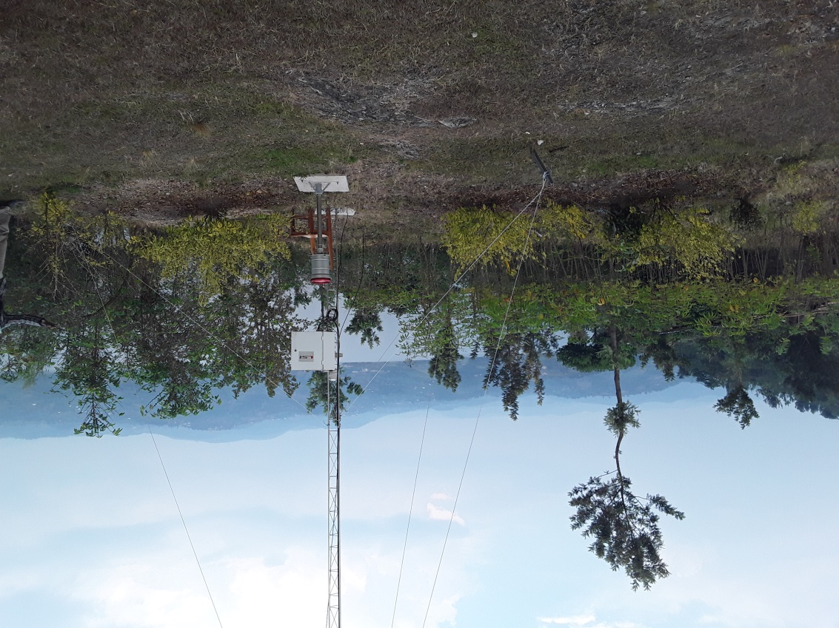
Bugarura Health Post/Rutsiro District

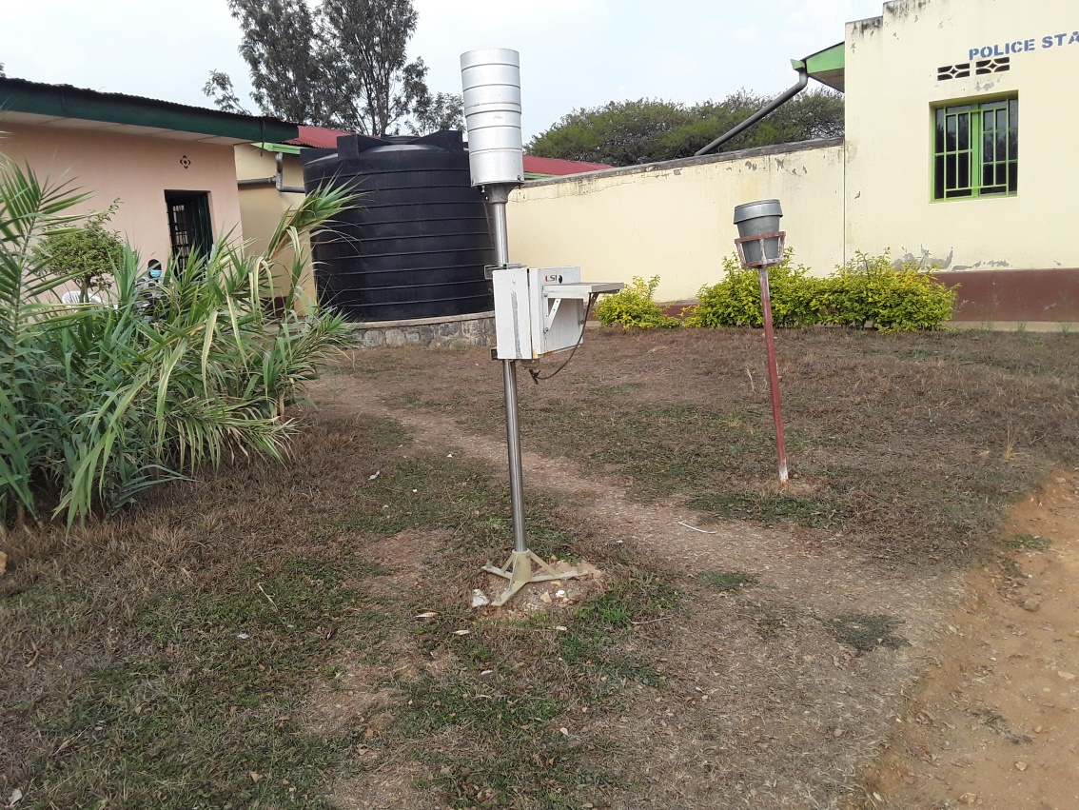
Kanjongo Sector/Nyamasheke District

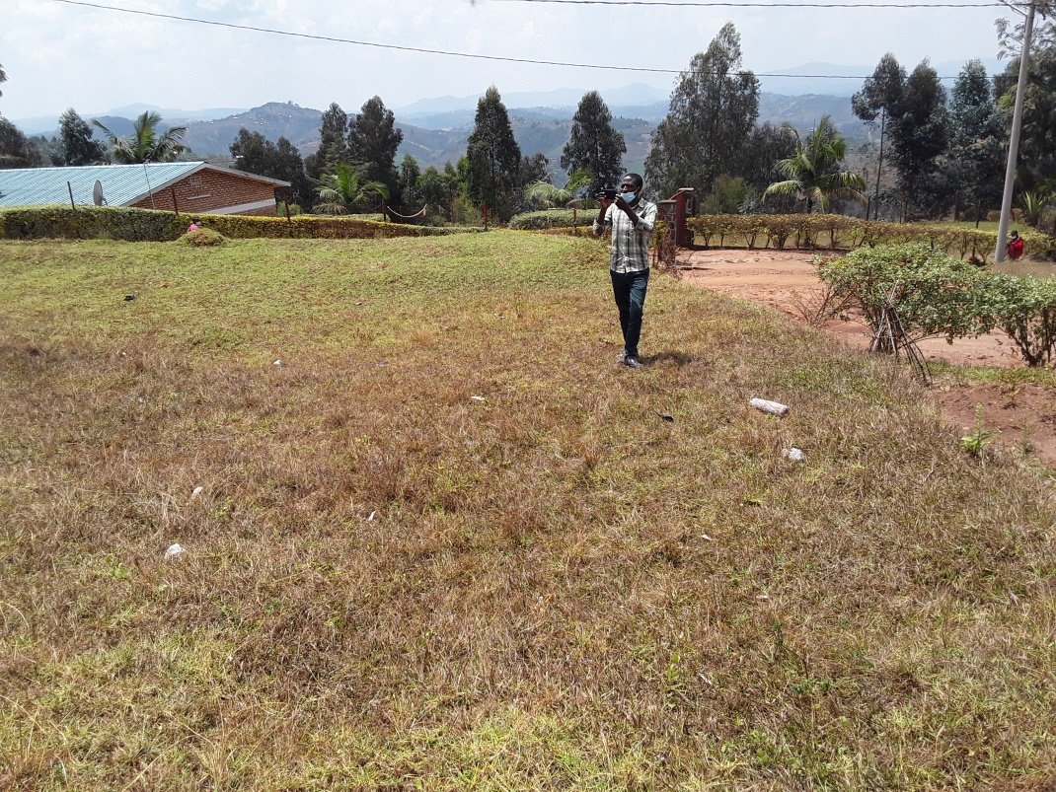
Munini Sector/Nyaruguru District

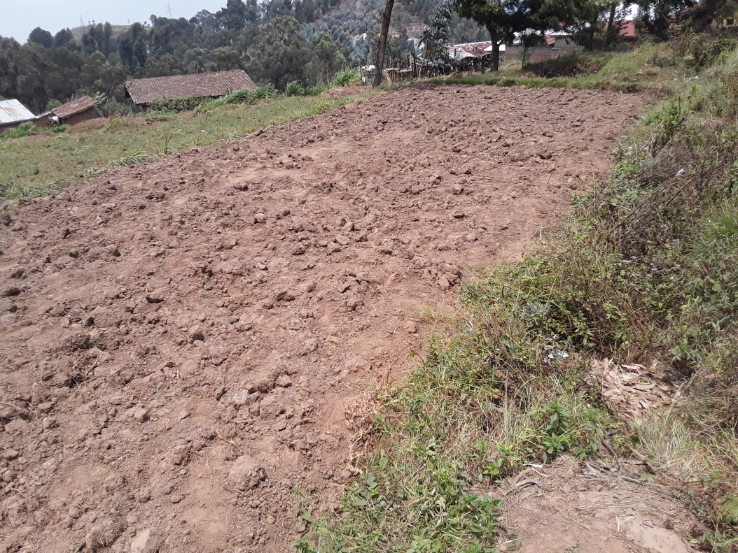
Rwankuba Sector/Karongi District

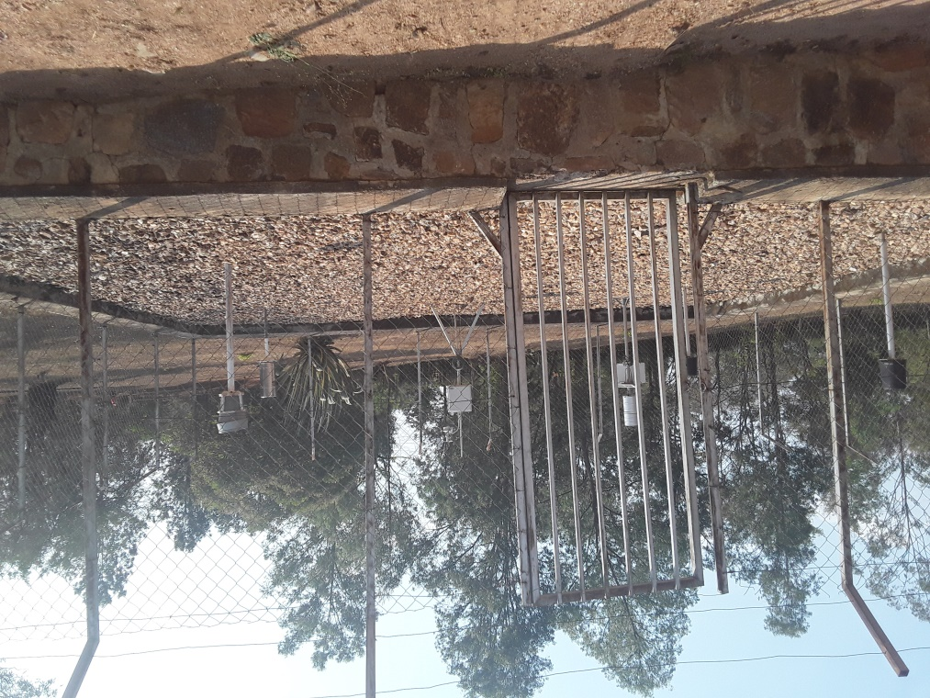
Ruhuha/Bugesera District

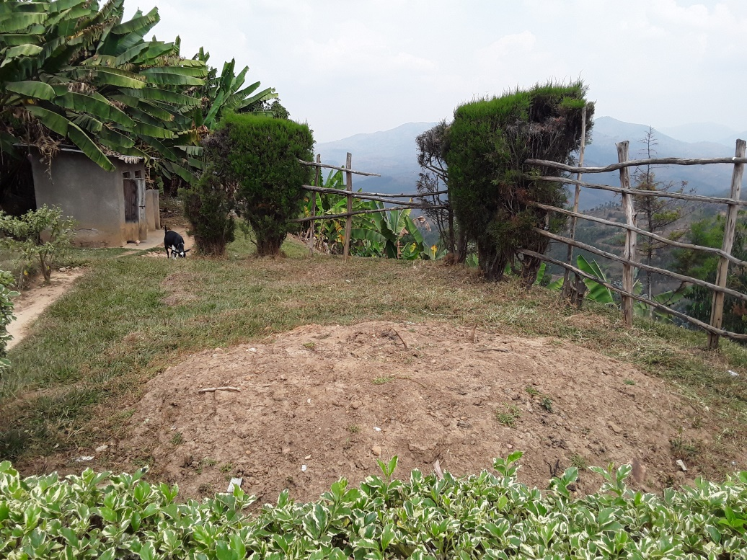
Ruganda Sector/Karongi

- Conclusion and Recommendations

In general we visited 10 sites including 4 new and 6 existing. We had much time to talk to local administration leaders on their engagement about the security of stations to be installed and they ensured total committment.
The security guard of Bugarura Health post where an Automatic Weather Station is installed and who keeps security of the station complains to not getting any motivation since the station was installed. We recommend the management to take into consideration of his complain.

After this exercise,we recommend the next step of preparing the sites by fencing identified sites before installation process.

Prepared by:

NTIRENGANYA Desire
Instuments Maintenance and Calibration Officer/Meteo Rwanda

UKWISHAKA David
Climate Change Data Officer/REMA

MUSONI Didace
DOQC&P Division Manager/Meteo Rwanda

